Attachment A: Recommended Modifications to the Notice of Determination

- Delete condition 2 of the Notice of Determination.

- Modify conditions 1, 8, 9, 19 and 67 of the Notice of Determination to read as follows:

1. |  |  | Approved plans and supporting documentation  Development must be carried out in accordance with the following approved plans and supporting documentation (stamped by Council), except where the conditions of this consent expressly require otherwise.  as modified by the following plans only in relation to changes to the configuration of Lots 7-14 and 33-38 and re-alignment of Road 3:  In the event of any inconsistency between the approved plans and the supporting documentation, the approved plans prevail. In the event of any inconsistency between the approved plans and a condition of this consent, the condition prevails.  Note: an inconsistency occurs between an approved plan and supporting documentation or between an approved plan and a condition when it is not possible to comply with both at the relevant time.
  Plan No. | Description | Prepared by | Dated:
  DA.1.03 REV E (RFI 4) | DA Masterplan Aerial | Venu Design Group | 31/01/25  (E2025/18729)
  DA.1.04 REV E (RFI 4) | DA Masterplan Lot Plan | Venu Design Group | 31/01/25
  10431 DA-C01 to C13 H | Civil Design – DA Plans | Ardill Payne & Partners | 5/2/2026
  10431 DA-C15 to C16-02 H | Civil Design – DA Plans | Ardill Payne & Partners | 5/2/2026
  10431 C103 A | Intersection Layout Plans 1 & 2 | Ardill Payne & Partners | 12/12/2024
  2025.1928 Final Issue A | On-site Sewage Capability Management Assessment Report (as amended by conditions) | HMC Environmental Consulting Pty Ltd | 27/1/2026
  HMCDWG 2023.1928 | On-site Sewage Capability Plan | HMC Environmental Consulting Pty Ltd | 27/1/2026
  Plan No. | Description | Prepared by | Dated:
  S455.1.03 (Rev A) | Masterplan – Aerial | Venu Design Group | 1/11/2025
  S455.1.03 | S4.55 Masterplan – Lot Plan | Venu Design Group | 1/11/2025
8. |  | Timing of Works  External roadworks within McAuleys Lane and Mullumbimby Road are to be completed prior to commencement of subdivision works that generate significant heavy vehicle traffic associated with road construction, subdivision servicing or civil works external to the site.  Notwithstanding the above, vegetation management works, site establishment works, and internal works may commence prior to completion of the external roadworks, provided:  - A Traffic Management Plan and Traffic Guidance Scheme prepared by a suitably qualified and accredited traffic practitioner is submitted to and approved by Council;  - All construction traffic is managed in accordance with the approved Traffic Management Plan;  - Heavy vehicles are not permitted to queue or stand within McAuleys Lane;  - Heavy vehicle arrivals and departures are coordinated to avoid conflicts with local traffic; and  - Council may require additional traffic management measures should safety concerns arise during construction.
9. | Amended Onsite Sewage Capability Plan  Prior to issue of any Subdivision Works Certificate, a revised On-site Sewage Management Capability Plan is to be submitted to and approved by Council, correcting the Lot CT.10 legend annotation and showing dimensioned separation distances from the nominated land application areas on Lots CT.10 and CT.37 to the 2nd order stream and to groundwater bore approval No. 30WA001941 respectively. The bore location is to be taken from the registered coordinates held by WaterNSW or from survey.
19. | Imported Fill Material  Prior to the issue of a Subdivision Works Certificate for each stage, the type of fill material to be used is to be nominated by a suitably qualified geotechnical engineer.  The fill is to be provided with certification that it is clean, uncontaminated, and suitable for use as engineering fill.  The nominated fill for areas that rely on infiltration is to be provided to the Certifying Authority for approval showing that the parameters of the fill on Lots 36 and 37, meet the minimum infiltration rates as required by the wastewater disposal.
67. | Management Statements  The management statement and development contract and a copy are to be submitted with the application for a subdivision certificate, together with a letter from a Solicitor, experienced in Community Title legislation, certifying that the management statement and development contract have been prepared in accordance with Community Title legislation and acceptable for registration with NSW Land and Property Information.  The Management Statement must include within the By-Laws required by a public authority provisions for:  - No Build Zones  No buildings or structures of any kind are permitted on the areas within the lots identified on Plan S455.1.03 Rev A Masterplan Lot Plan, as “no build zone”.  - Effluent Disposal Area  Restrictions to limit any development, other than effluent disposal systems and associated works, to the nominated effluent disposal areas on all lots, as shown in the On-Site Sewage Management Capability Assessment by HMC Environmental Consulting Pty Ltd dated 27/1/2026.  - Advanced Secondary Treatment  Minimum wastewater treatment required for all lots to be advanced secondary treatment of effluent prior to discharge to a Council approved disposal method. The systems to incorporate the following features:  - Each lot must install a NSW accredited on-site sewage management system which achieves a nutrient reduction rate of no less than 67% and disinfection in the treatment system;  - Any land application areas located within 250 m of licensed groundwater bores or within 100m of permanent surface waters must only dispose of effluent which has been treated to an advanced secondary treatment standard with final disinfection prior to discharge  - Community On-site Wastewater Management Plan  The Community On-site Wastewater Management Plan (the Plan) must be prepared by a suitably qualified and experienced professional for approval by Council.  The Plan must adopt provisions for:  - Environmental Protection: To reduce the risk of pollution to water bodies and groundwater.  - Public Health: To minimise the risk of waterborne diseases and other health hazards.  - Property Values: To encourage well-maintained on-site systems to help maintain property values  - Community Sustainability: To promote sustainable practices and resource conservation.  The Plan must include (but not be limited by):  - Inventory and Assessment: Steps to identify and assess the condition of existing on-site wastewater systems within the community.  - Regulatory Compliance: Steps to ensure compliance with local, state, and federal regulations governing on-site wastewater systems.  - Maintenance and Operation: Steps to establish guidelines and procedures for the proper maintenance and operation of on-site systems to minimise environmental impact and public health risks.  - Monitoring and Inspection: Steps to implement a program to monitor the performance of on-site systems and conduct regular inspections to identify potential issues.  - Education and Outreach: Steps to provide education and outreach to community members about the importance of proper wastewater management and system maintenance.  - Future Planning: Steps to develop a long-term plan for the management of on-site wastewater systems, including potential upgrades or alternative solutions as needed  - Use of Dwellings  Provisions to prohibit holiday letting / short term rental accommodation or use of dwellings as tourist and visitor accommodation other than that permitted under State Environmental Planning Policy (Housing) 2021.  - Keeping of Cats and Dogs  Provisions to prohibit the keeping of cats and dogs other than assistance animals as defined under the Companion Animals Act 1988.  - Vegetation Management Plan  Provisions requiring that the Executive Committee shall be responsible for the implementation and management of the Vegetation Management Plan provided that the proprietors of Neighbourhood Lots shall be responsible for the implementation of the Vegetation Management Plan to the extent that it applies to such Neighbourhood Lots.

- Insert the following conditions into the Notice of Determination in appropriate order:

57A. | Fill placed within nominated land application areas and reserve land application  areas on Lots CT.35 to CT.38 is to be placed strictly in accordance with the LAA  Site Filling Specification on Drawing DA-C16-02 Issue J (or later approved  revision). Fill material is to be non-dispersive, friable, sourced from the deep  clay loam profiles present on site, and approved in writing by the project OSSM  consultant prior to placement. The stripped natural surface beneath land  application areas is to be scarified or lightly ripped immediately prior to fill  placement and is not to be compacted.
57B. | Nominated primary and reserve land application areas on all lots are to be  protected during construction. These areas are to be identified on the ground  and fenced or flagged prior to commencement of earthworks and are not to be  used for the trafficking of construction plant, stockpiling of materials, or location  of site facilities.
64A. | Prior to issue of the subdivision certificate, land application area construction  within filled areas on Lots CT.35 to CT.38 is to be certified by a suitably qualified  environmental consultant, confirming that fill within the designated land  application areas has been placed in accordance with the approved LAA Site  Filling Specification and the requirements of the HMC Environmental On-site  Sewage Capability Assessment Report No. 2025.1928.
64B. | Prior to issue of the subdivision certificate, a restriction on the use of land and  positive covenant under section 88B of the Conveyancing Act 1919, or an  equivalent provision within the Community Management Statement, is to be  created over Lots CT.35 to CT.38 identifying the land application area fill zones  and prohibiting compaction, excavation, structures, driveways and retaining  walls within those zones.
71A. | The works-as-executed plan for the subdivision is to clearly delineate the extent of  land application area fill placed under the LAA Site Filling Specification from  controlled fill placed under the General Allotment Filling Specification Level 1,  on each of Lots CT.35 to CT.38.
86A. | Reserve land application areas as nominated on the OSSM layout plan are to  remain free of permanent structures, including dwellings, driveways, retaining  walls, swimming pools and ancillary buildings.
86B. | The on-site sewage management system for all lots is to incorporate an Aerated  Wastewater Treatment System with current NSW Health accreditation for total  nitrogen reduction of not less than 53%, and shallow pressure-compensated  sub-surface drip irrigation as the effluent land application method, unless an  alternative system is demonstrated to be appropriate through a merit-based site  and soil assessment at individual dwelling development application stage.

- Modify Schedule 4 of the Notice of Determination to read as follows:

Schedule | 4. INTEGRATED DEVELOPMENT GENERAL TERMS OF APPROVAL
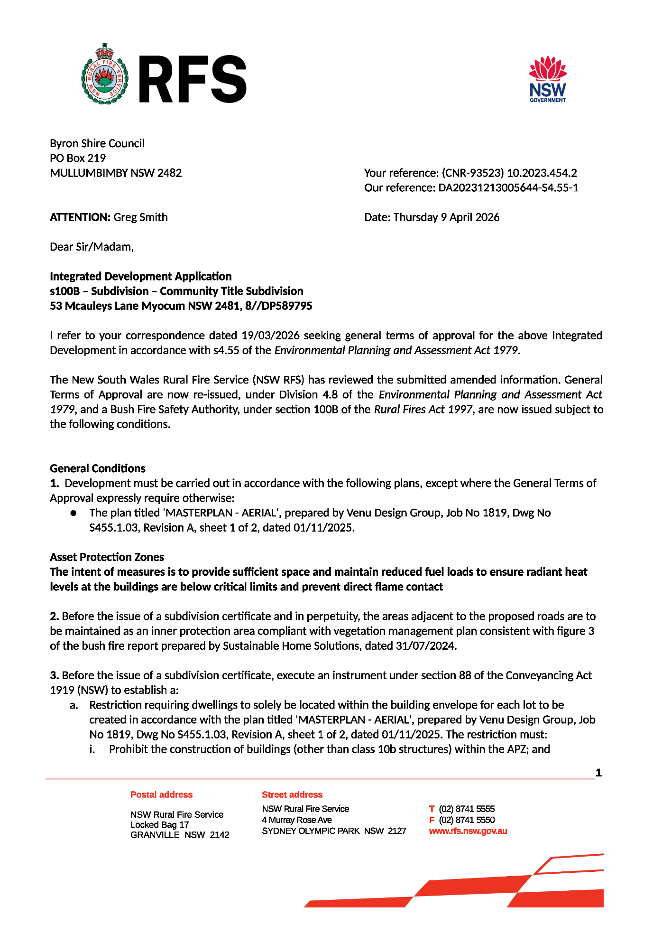

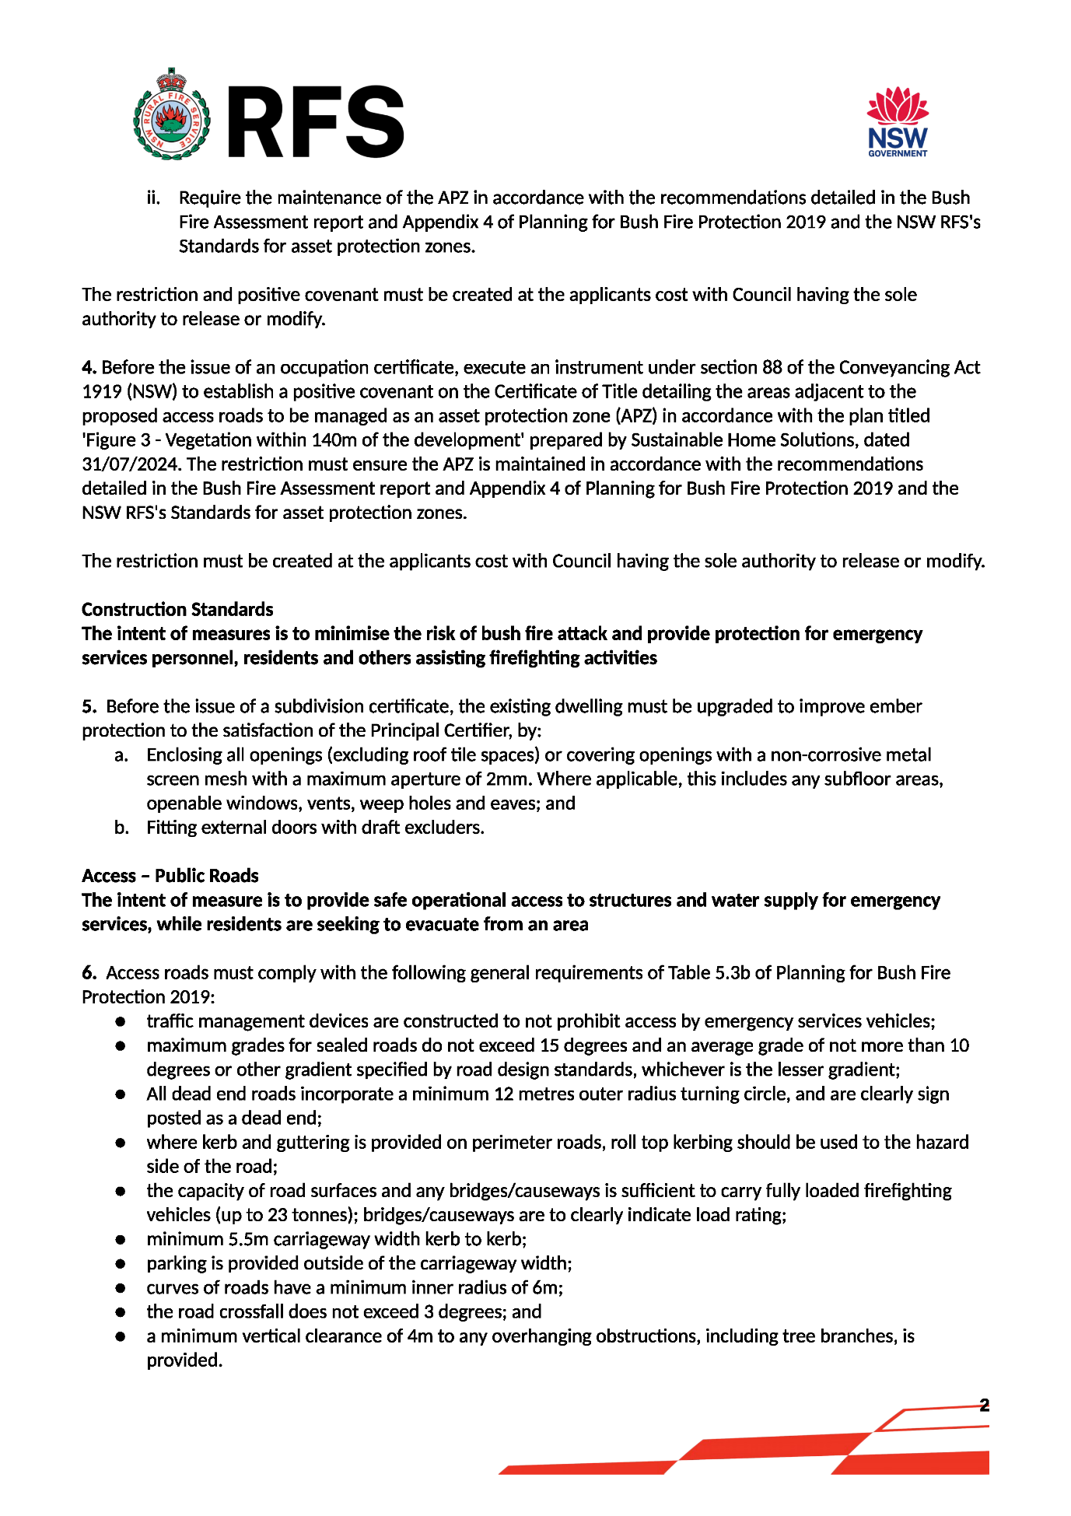
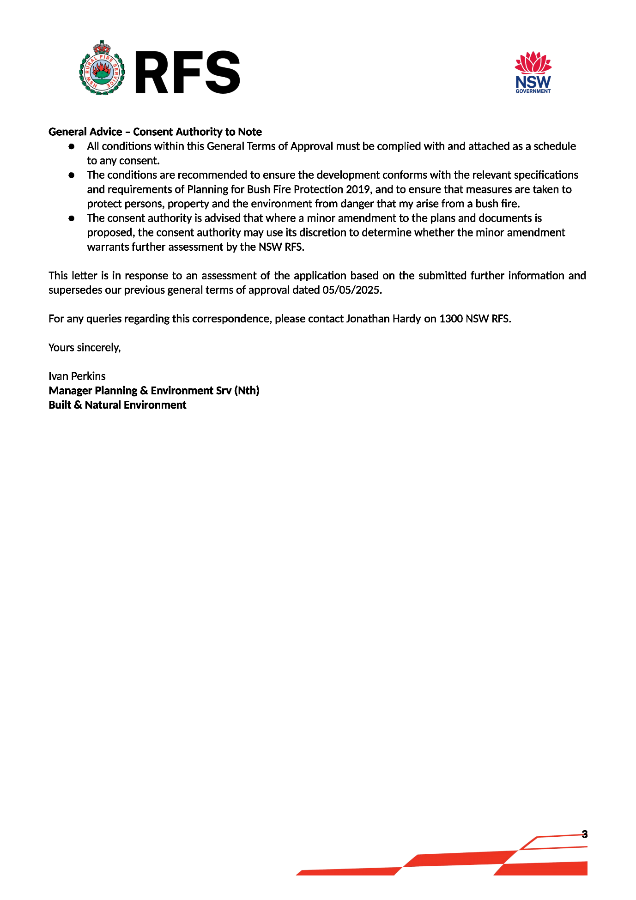
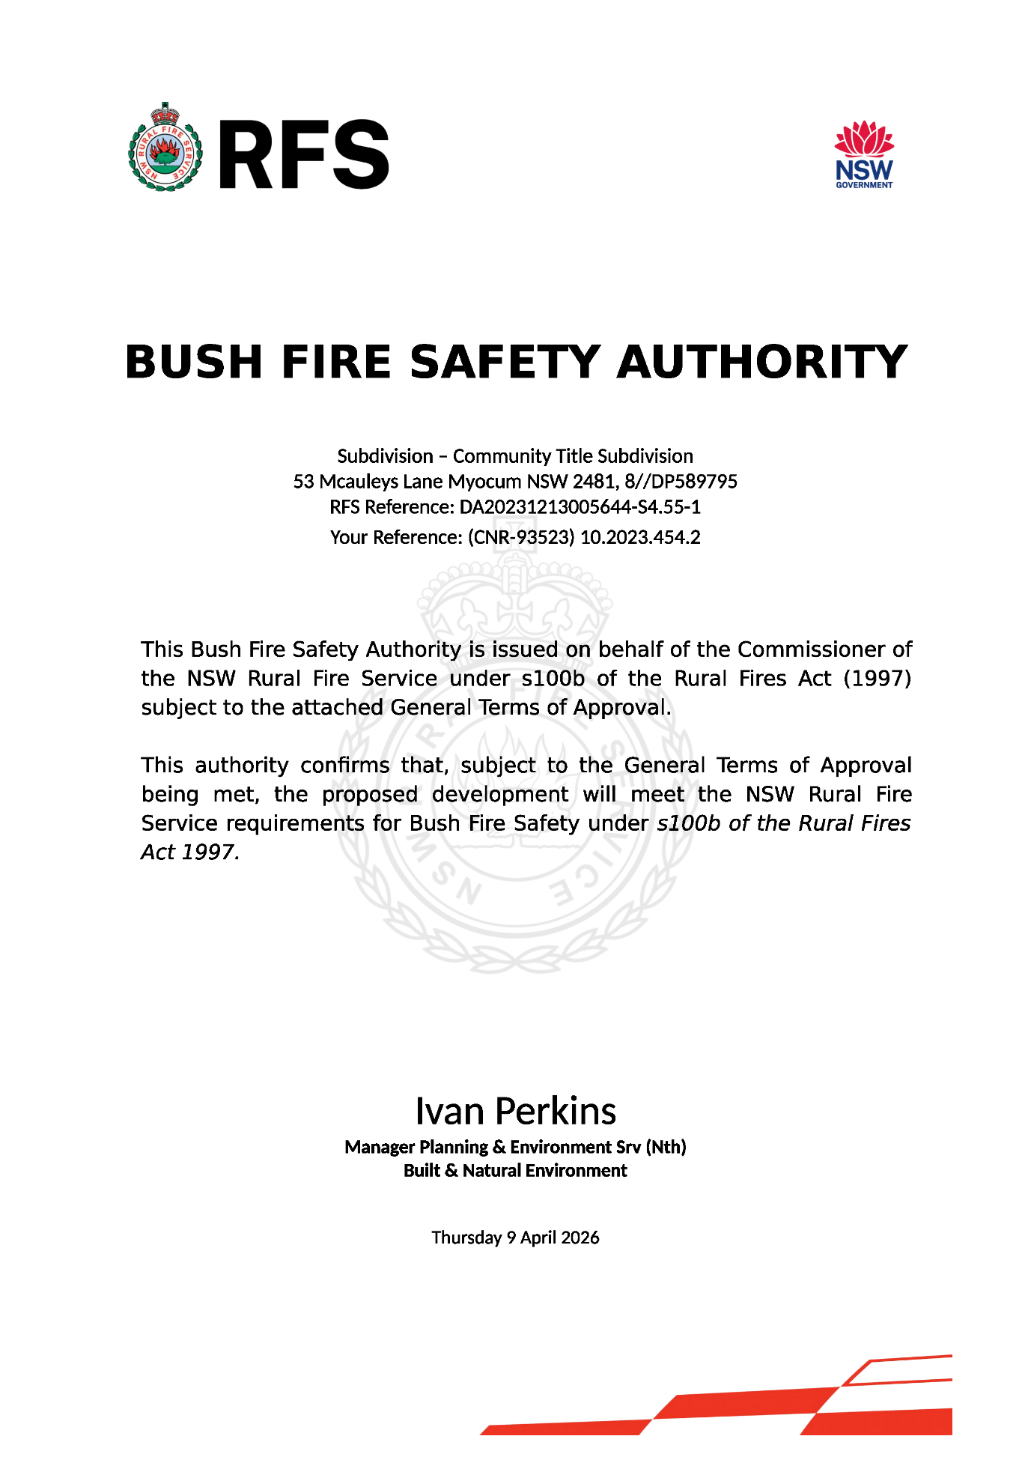

- Modify the Notes in Schedule 7 of the Notice of Determination titled “Essential Energy” and “S7.11 Schedule of Development Contributions” to read as follows:

Essential Energy

- As the plans provided do not show the distances from Essential Energy’s infrastructure and the development, there may be a safety risk. A distance of 7.5m from the nearest part of the development to Essential Energy’s infrastructure (measured horizontally from the centre line) is required to ensure that there is no safety risk.

An easement of 15m overall is required from the low voltage overhead network located within the proposed subdivision.

- It is also essential that all works comply with SafeWork clearance requirements. In this regard it is the responsibility of the person/s completing any works to understand their safety responsibilities. The applicant will need to submit a Request for Safety Advice if works cannot maintain the safe working clearances set out in the Working Near Overhead Powerlines Code of Practice, or CEOP8041 - Work Near Essential Energy's Underground Assets.

Information relating to developments near electrical infrastructure is available on our website Development Applications (essentialenergy.com.au). If the applicant believes the development complies with safe distances or would like to submit a request to encroach then they will need to complete a Network Encroachment Form via Essential Energy’s website Encroachments (essentialenergy.com.au) and provide supporting documentation. Applicants are advised that fees and charges will apply where Essential Energy provides this service.

Council’s and the applicant’s attention is also drawn to Section 49 of the Electricity Supply Act 1995 (NSW). Relevantly, Essential Energy may require structures or things that could destroy, damage or interfere with electricity works, or could make those works become a potential cause of bush fire or a risk to public safety, to be modified or removed.

Essential Energy makes the following general comments:

- If the proposed development changes, there may be potential safety risks and it is recommended that Essential Energy is consulted for further comment;

- Any existing encumbrances in favour of Essential Energy (or its predecessors) noted on the title of the above property should be complied with;

- Any activities in proximity to electrical infrastructure must be undertaken in accordance with the latest industry guideline currently known as ISSC 20 Guideline for the Management of Activities within Electricity Easements and Close to Infrastructure;

- Prior to carrying out any works, a “Dial Before You Dig” enquiry should be undertaken in accordance with the requirements of Part 5E (Protection of Underground Electricity Power Lines) of the Electricity Supply Act 1995 (NSW); the location of overhead and underground powerlines are also shown in the Look Up and Live app essentialenergy.com.au/lookupandlive.

- Note: If your site’s energy demand exceeds Essential Energy’s standard limits, electricity supply upgrades may be required, including the possible installation of a padmount substation within your development. It is advised to use Essential Energy’s Connection portal early to identify network needs and plan accordingly. Should network augmentation be necessary, consult the current list of Accredited Service Providers (ASPs) at https://www.energy.nsw.gov.au/households/guides-and-helpful-advice/being-more-energy-efficient/understand-your-energy-bill/altering-supply to arrange the necessary works."

Essential Energy makes the following general comments regarding the proposed subdivision:

- As part of the subdivision, an easement is created for any existing electrical infrastructure. The easement is to be created using Essential Energy’s standard easement terms current at the time of registration of the plan of subdivision;

- If the proposed development changes, there may be potential safety risks and it is recommended that Essential Energy is consulted for further comment;

- Any existing encumbrances in favour of Essential Energy (or its predecessors) noted on the title of the above property should be complied with;

- All Torrens lots must have access and frontage to a public road as per Service and Installation rules this is to allow for the provision of power/services to the new development, a right of carriageway can not to be used for the provision of power/services to any part of the new development.

- Council should ensure that a Notification of Arrangement (confirming satisfactory arrangements have been made for the provision of power) is issued by Essential Energy with respect to all proposed lots which will form part of the subdivision, prior to Council releasing the Subdivision Certificate. It is the Applicant’s responsibility to make the appropriate application with Essential Energy for the supply of electricity to the subdivision, which may include the payment of fees and contributions;

- In addition, Essential Energy’s records indicate there is electricity infrastructure located within the property. Any activities within this location must be undertaken in accordance with the latest industry guideline currently known as ISSC 20 Guideline for the Management of Activities within Electricity Easements and Close to Infrastructure;

- Prior to carrying out any works, a “Dial Before You Dig” enquiry should be undertaken in accordance with the requirements of Part 5E (Protection of Underground Electricity Power Lines) of the Electricity Supply Act 1995 (NSW);

- Given there is electricity infrastructure in the area, it is the responsibility of the person/s completing any works around powerlines to understand their safety responsibilities. SafeWork NSW (www.safework.nsw.gov.au) has publications that provide guidance when working close to electricity infrastructure. These include the Code of Practice – Work near Overhead Power Lines and Code of Practice – Work near Underground Assets.

- "Note: If your site’s energy demand exceeds Essential Energy’s standard limits, electricity supply upgrades may be required, including the possible installation of a padmount substation within your development. It is advised to use Essential Energy’s Connection portal early to identify network needs and plan accordingly. Should network augmentation be necessary, consult the current list of Accredited Service Providers (ASPs) at https://www.energy.nsw.gov.au/households/guides-and-helpful-advice/being-more-energy-efficient/understand-your-energy-bill/altering-supply to arrange the necessary works."

Should you require any clarification, please do not hesitate to contact us.
Information about when and how to request safety advice from Essential Energy.
Request for Safety Advice (essentialenergy.com.au)

S7.11 Schedule of Development Contributions
The following contributions are current at the date of this consent. The contributions payable will be adjusted in accordance with the relevant plan and the amount payable will be calculated on the basis of the contribution rates that are applicable at the time of payment. The current contribution rates are available from Council offices during office hours.

Payments will be accepted through BPAY, over the telephone or in person at Council’s administration building. You will need to complete the Developer Contributions update and payment request form or www.byron.nsw.gov.au/contributions to confirm the total contribution amount due and request an invoice with payment details.

